

1. **Paste rice to all fruits.**

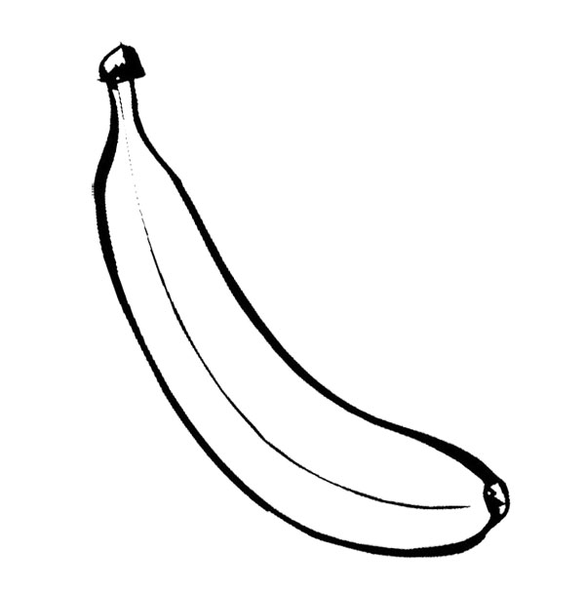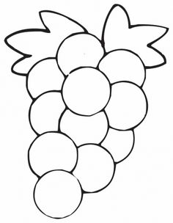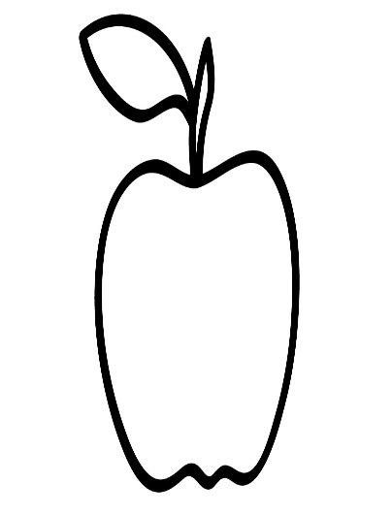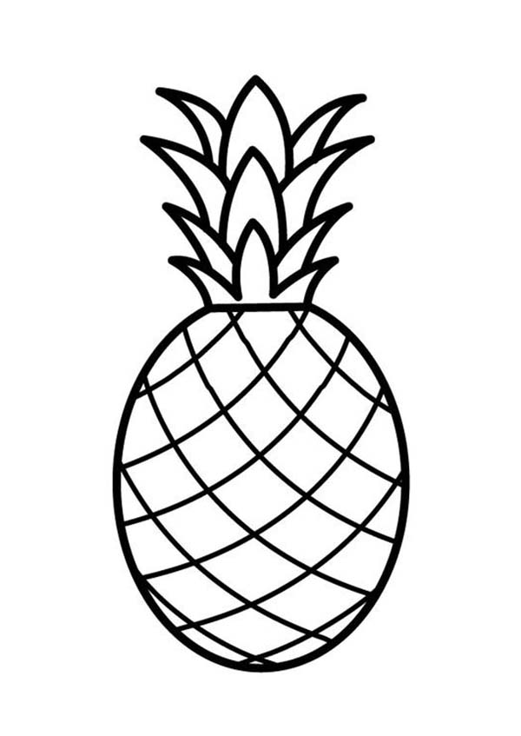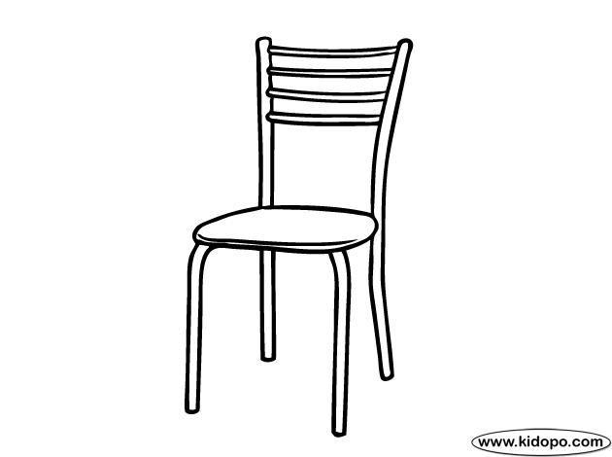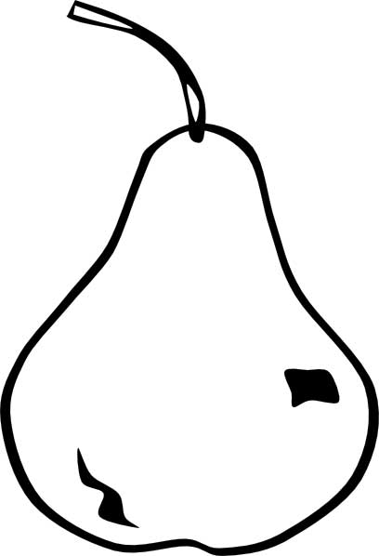

**New Horizon School Aguazul-Casanare**

**Final Test**

**Name**: _____________________________________________________________

**Date**: ______________________________ **Grade**: Prekinder

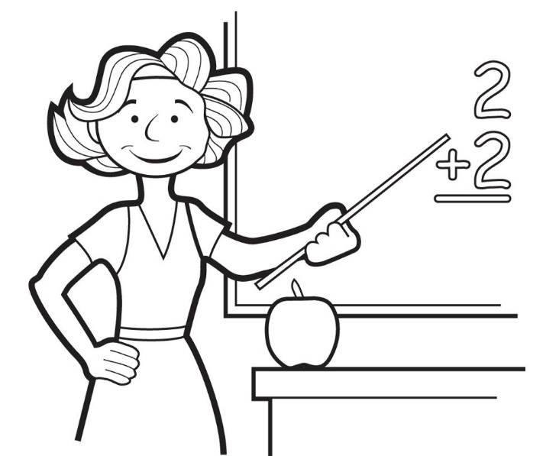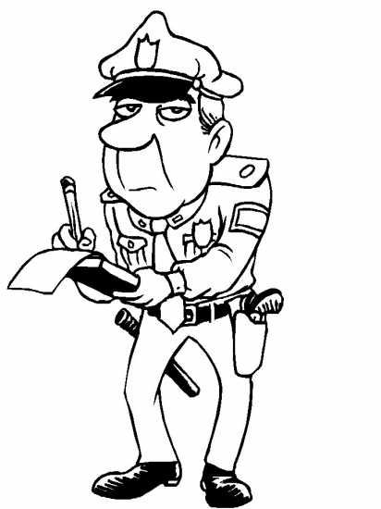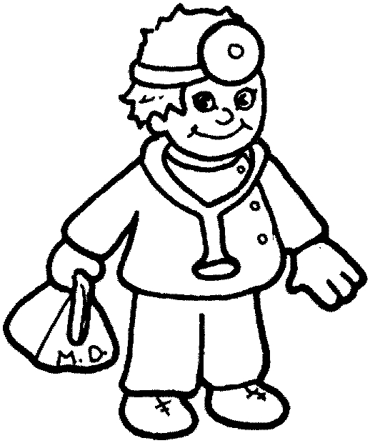



**2. Color the police officer.**

**3. Color the teacher**

**4. Color the doctor**



**5. Color.**

